**Cisco Network-Predictive Analysis Model**

**Project Showcase – January 17th, 2018**

**Narrative**

To develop a probabilistic scoring predictive model that would predict early element failure (green zone) rather than determining failure late (red zone) when the machine has already crashed. The telemetry data was taken from sections of Cisco’s leaf-spine architecture.

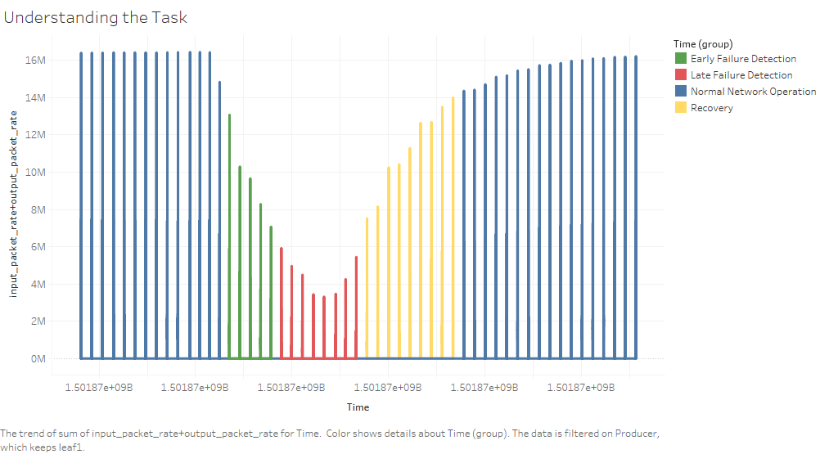

**References**

* Project documentation and Python code:

https://github.com/nanduriprabhakar/Data_Science_Team_Project

* Cisco Network Data-set [Open Source]:

https://github.com/cisco-ie/telemetry

**Presented By**

1. Prabhakar Narasimha Nanduri

Duke University - Master of Engineering Management Candidate

(919)-433-7616 || prabhakar.nanduri@duke.edu

https://www.linkedin.com/in/prabhakar-nanduri/

https://github.com/nanduriprabhakar

1. Manan Vasani

Duke University - Master of Engineering Management Candidate

(919)-381-7864 || manan.vasani@duke.edu

https://www.linkedin.com/in/mananvasani/